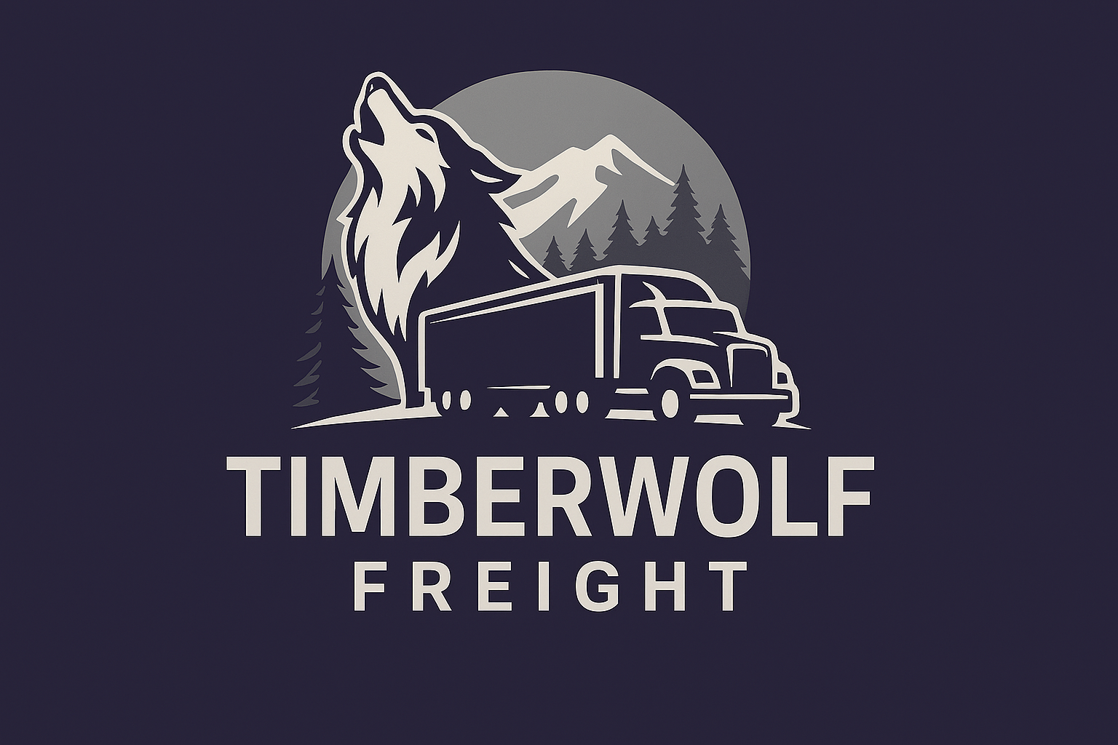

# Timberwolf Freight – Capabilities Statement

## Company Overview

Timberwolf Freight is a lean, independent freight brokerage based in the Midwest, built to move fast and deliver unmatched value. We provide logistics solutions that are smart, lean, and relentlessly tailored to meet the dynamic needs of agriculture, manufacturing, food, and building supply shippers across the region.

## Core Services

- Full Truckload (FTL) Brokerage  
- Dry Van, Reefer, and Flatbed Capacity  
- Regional & National Freight Coverage  
- Spot & Contract Rate Solutions  
- Carrier Sourcing and Vetting  
- 24/7 Communication & Tracking

## Industries Served

- Agriculture (grain, feed, farm supplies)  
- Building Materials (lumber, beams, metal)  
- Food & Beverage (dry, refrigerated)  
- Light Manufacturing

## Why Timberwolf?

- Personal touch  
- Lean operations for maximum responsiveness  
- Relentless pursuit of performance and trust

## Company Info

Founder: Jason Ostergren  
Location: Minnesota, USA  
Email: jason.ostergren@timberwolffreight.com  
Website: www.timberwolffreight.com  
Phone: (612) 282-2704  
MC Number: 1746104USDOT: 4435963

Smart. Lean. Relentless.